
LAB MID

Submitted by:
Submitted by:

Name | Registration No.
Muhammad Abdullah | FA24-BSE-042

Submitted to: Anayat Ullah
Course: Information security
Dated: April 6, 2026.

DEPARTMENT OF COMPUTER SCIENCE
COMSATS UNIVERSITY ISLAMABAD,
ISLAMABAD CAMPUS

QUESTION 1:

Hashtype:
32 Characters = MD5

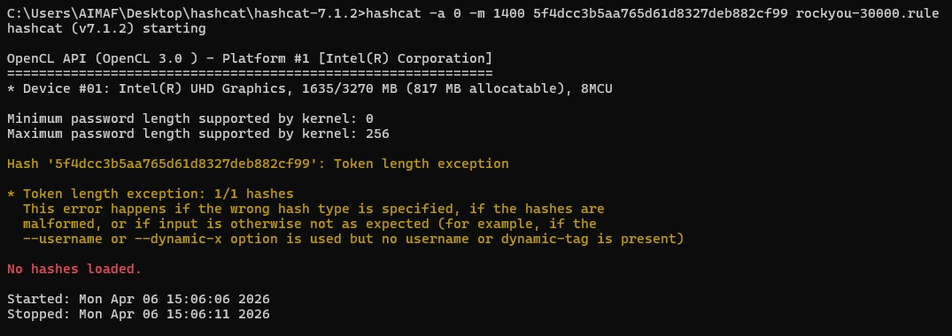
ddasdadsadasdasdasd

Dictionary Attack:

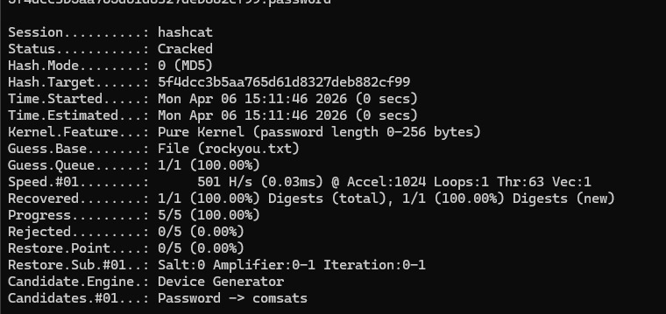

Brute Force Attack:
ddasdadsadasdasdasd

Combination Attack:
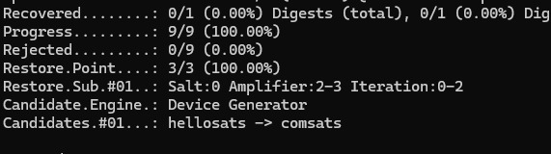
Cracked passwords:


QUESTION 2:
2.1:
Working & VERIFICATION:
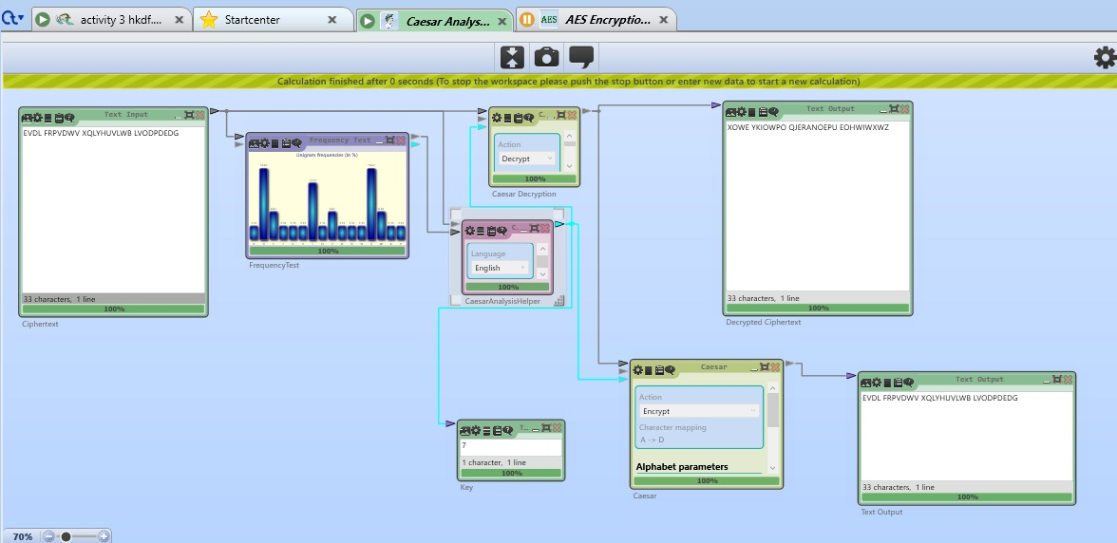
Likely Key values are: v & d

2.2:
Encryption & Decryption:
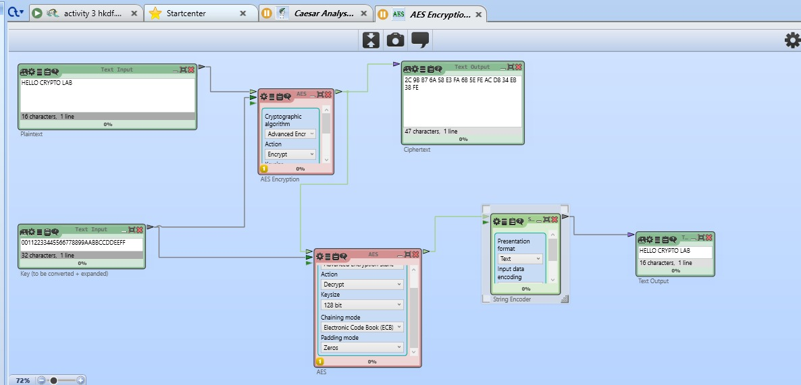

QUESTION 3:
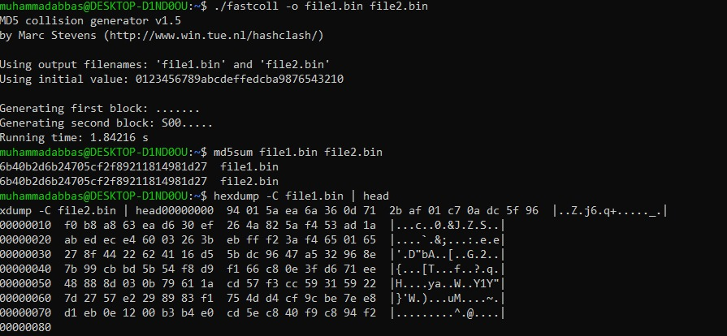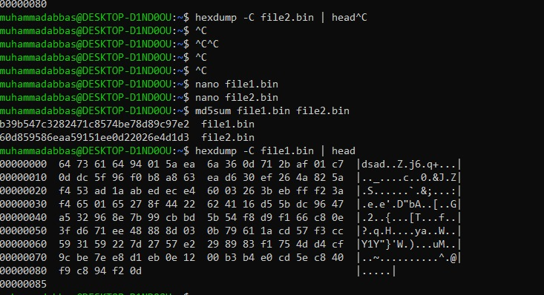

QUESTION 4:

Encryption & Decryption:
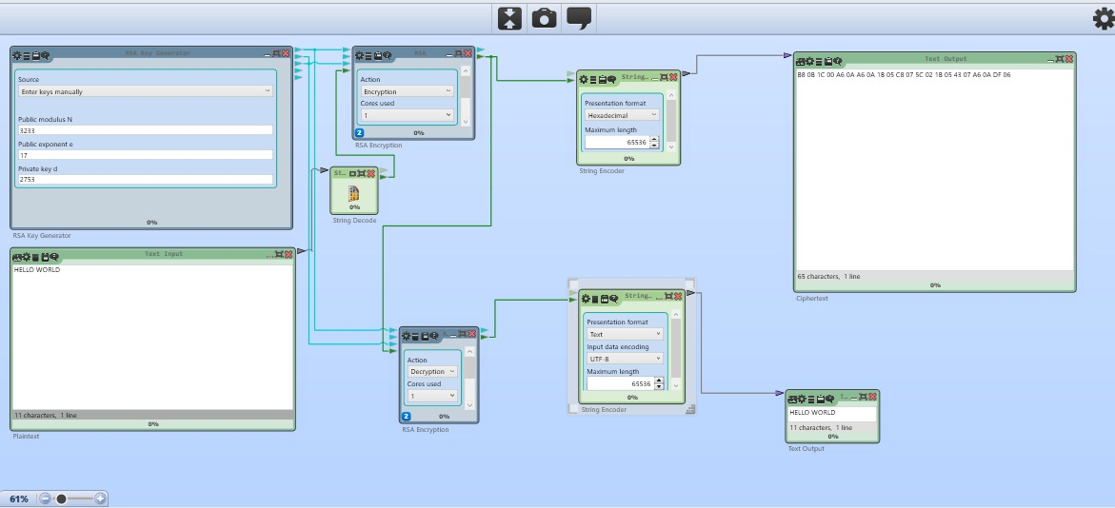

QUESTION 5:
Compaign results:
